**Kafka and Zookeeper are installed**

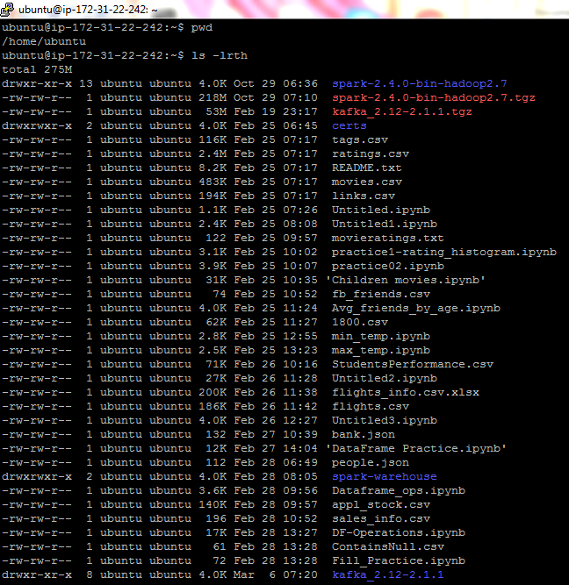

1. **Starting Zookeeper and Kafka**

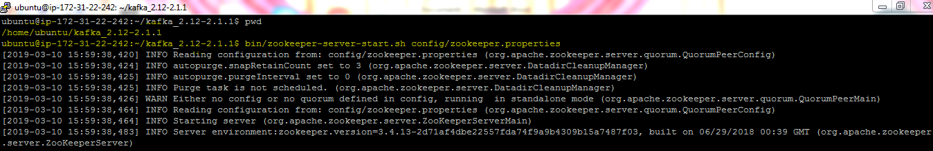

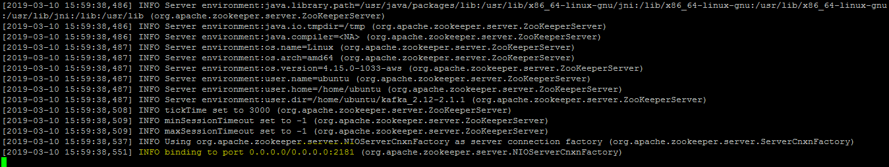

Zookeeper is running now

Starting Kafka server in another putty session

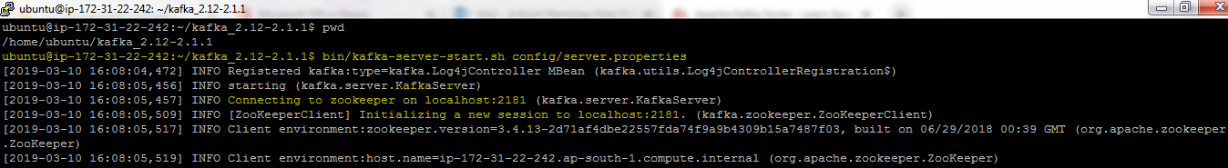

This will initialize 1 broker with brokerID=0

1. Make sure zookeeper and kafka are running.
2. Creating,describing,listing and deleting topics TOPICS

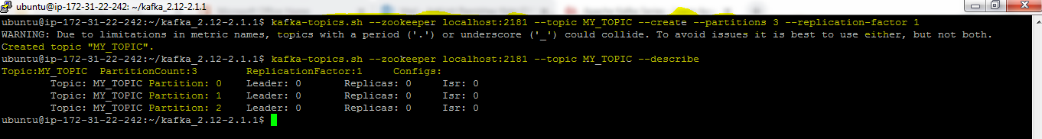

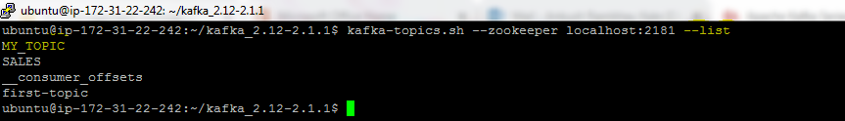

[Topics SALES and first-topic are part of earlier kafka practice]

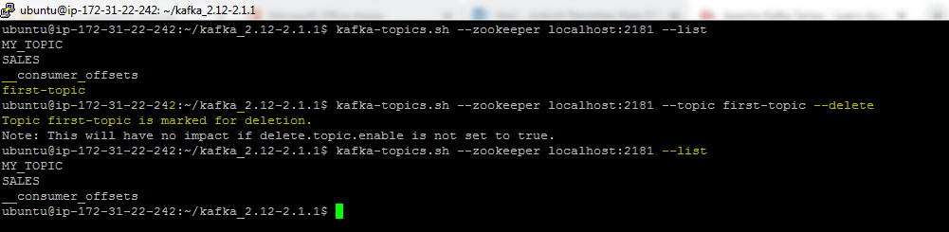

1. Producers

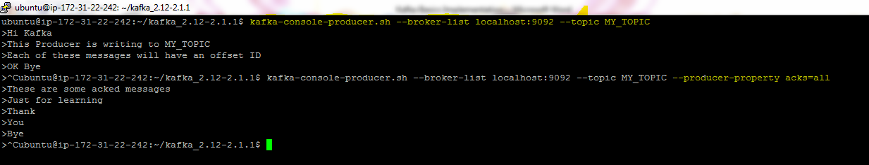

1. Consumer

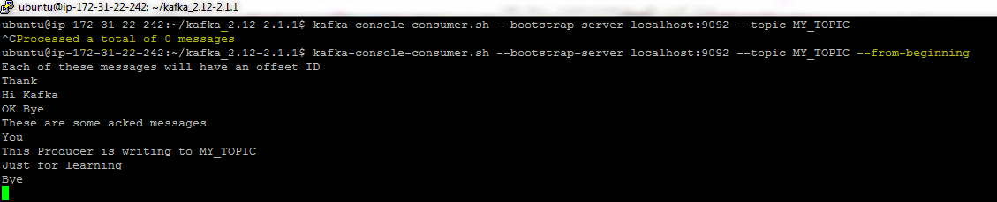

[In first consumer, 0 messages processed since no PRODUCER was producing. In second case, --from-beginning option will read all the messages stored in broker(partitions) from beginning]

1. Produce messages and read with consumer (kind of real time)

Open 1 session for producer and 1 for consumer.

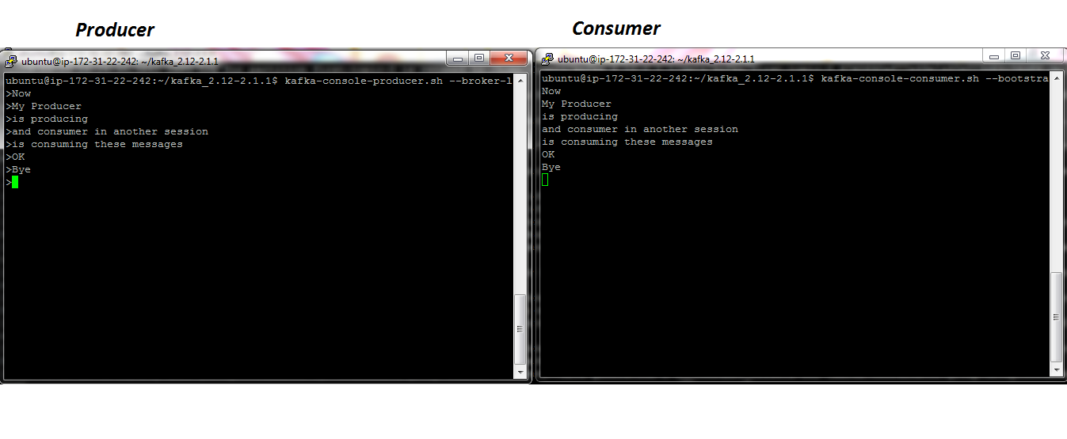

1. Consumer Groups

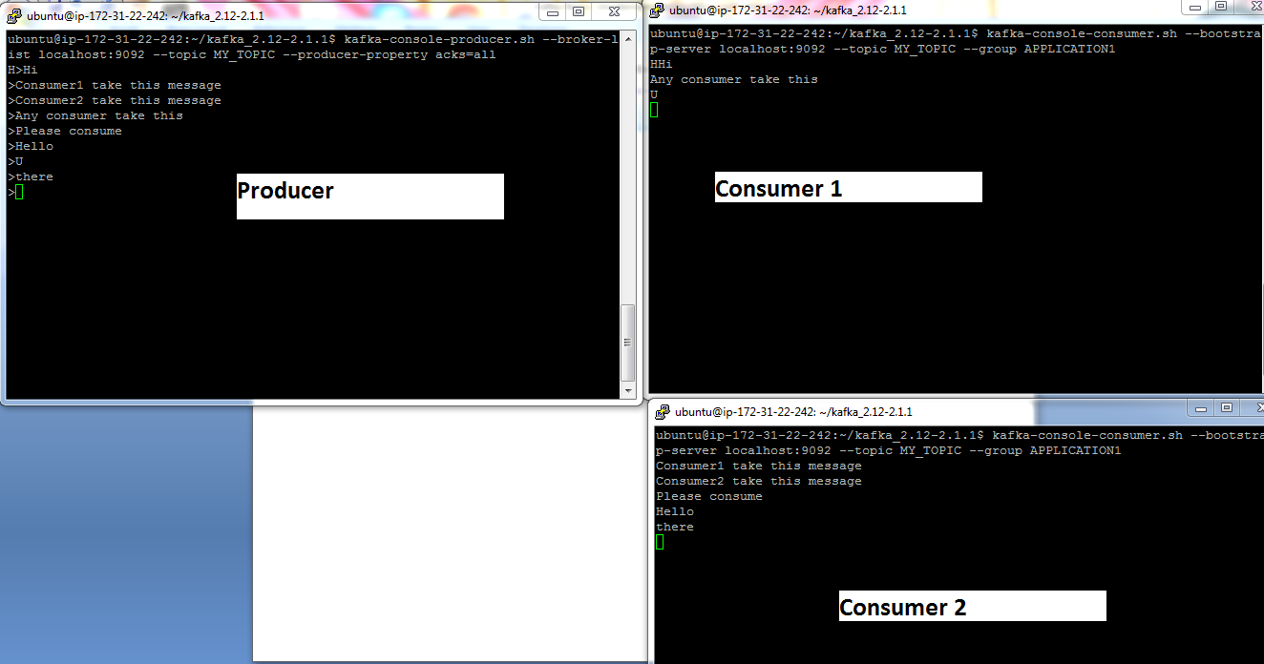

Here Producer is producing and consumer group APPLICATION1 is consuming. So, there are two consumers in APPLICATION1 group who are distributing the consume load. I.e some messages are entertained by consumer 1 and some are by consumer 2

If one of the consumer gets down, other consumer starts taking all the messages.